**LATEST NEWS**

**December 2017**

**Site visit to potash mine project in Eritrea** 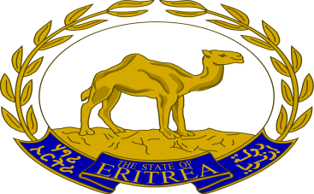

Optima staff visited the proposed potash mine project site in Eritrea. As part of the Independent Environmental Health, Social and Safety Consultant (IESC) team, Optima staff members from Seattle, WA and Asmara, Eritrea visited the proposed sites for potash mine and desalination water plant. Visit included meetings with country government officials and local village representatives as part of the due diligence review of the Environmental and Social Impact Assessment (ESIA) report and Bankable Feasibility Studies (BFS) report.

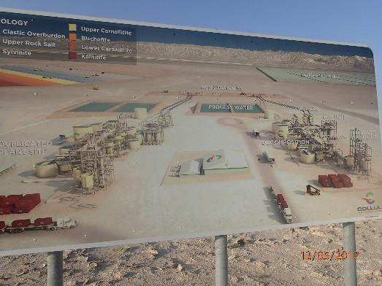

Illustration of the mine processing site.

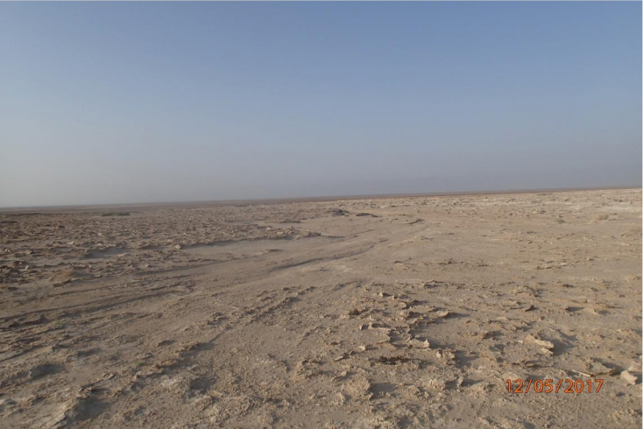

Existing condition at the mine site

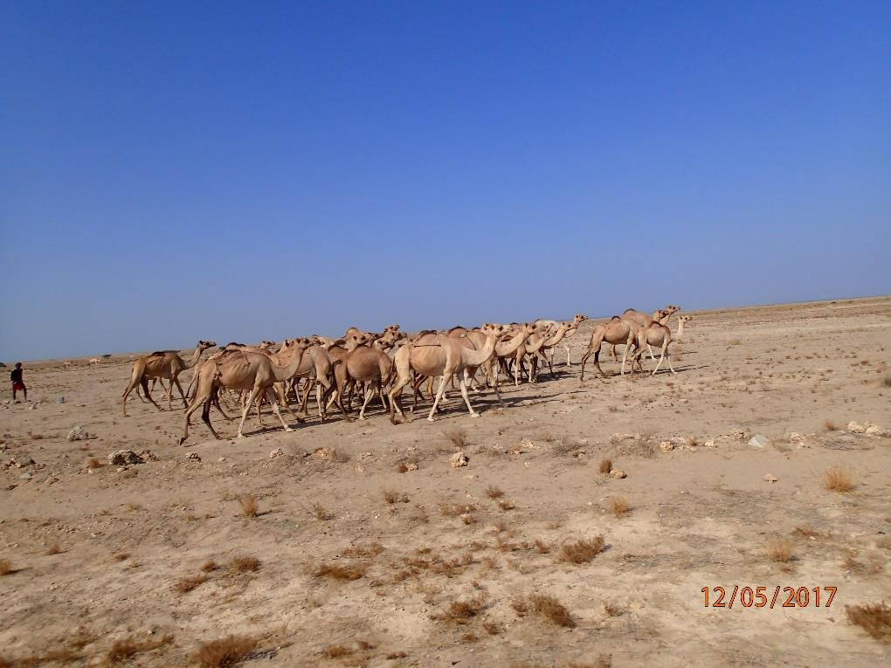

Camel herd near the proposed desalination water plant

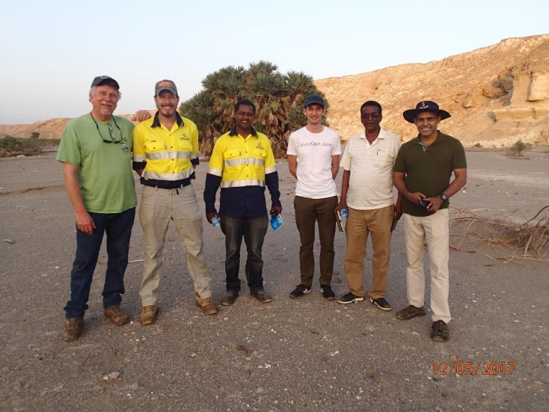

IESC and the mine project team on the Sariga River bed oasis.

September 2017 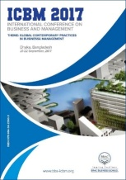

**Presentation at International Conference on Business and Management, BRAC University, Dhaka**

Aleya Ikbal, VP of Optima, presented the paper titled Performance Framework for Driving Results: How Seattle IT is improving performance using the framework approach at the 1st International Conference on Business and Management organized by BRAC University in Dhaka on Sep 21-22, 2017. She also led the panel discussion on ……… The event was attended by ………………..

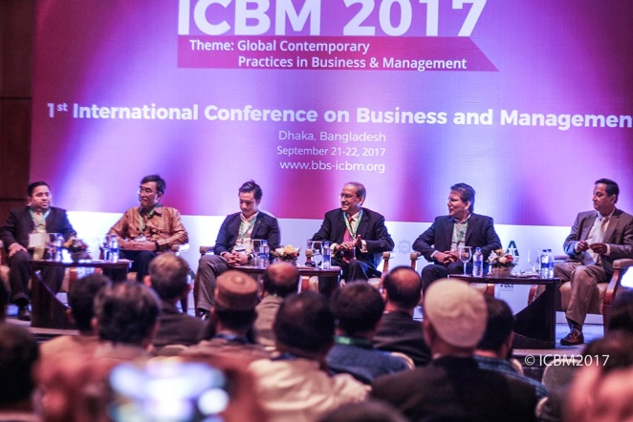

Inaugural session of the conference

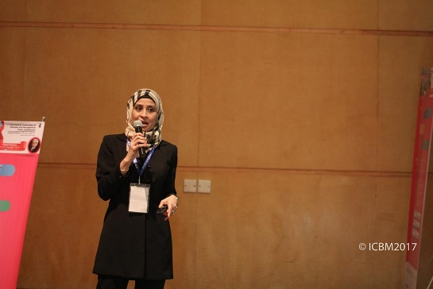

Aleya Ikbal presenting at ICBM

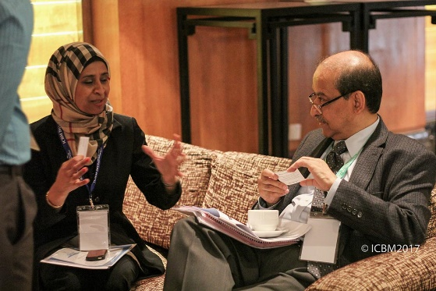

Aleya Ikbal having followed up discussion with the Vice-Chancellor of BRAC University.

July 2017

**Completion of Fremont Siphon Sewer Replacement Project, Seattle, Washington**

Construction of the Fremont Siphon Sewer Replacement by the King County Wastewater Division was recently completed. Optima staff provided Engineering Services during Construction (ESDC) for construction of two 60-in diameter tunnels under Lake Washington Ship Canal using remote controlled micro-tunneling boring machine (MTBM). The project began in early 2015 and also included replacement of the 108-in sewer interceptor, 30-in combined sewer overflow (CSO) pipe and construction of a new odor control facility.



Micro-Tunnel Boring Machine (MTBM) in the retrieval shaft



Installation of 108-in dia. sewer interceptor



New odor control facility above the sewer siphon